Replication with Byzantine Paxos - Current Status and Estimation

Dalei Yang
23 May 2016
Introduction
I introduced background knowledge, system architecture in previous document. This document includes: 1. Which features has been done. 2. Estimation for remaining features. 3. Operation automation. 4. Integrate with existing systems. My total estimation for whole system is 1 year / 1 person.
Contents
Byzantine paxos algorithm 1
High-Performance In-Memory cache 2
High-Performance API service 3
Operation automation 4
Integration with existing systems 4
References 4

Byzantine paxos algorithm
There is internal component for one replica and a demo distribute system with four replicas.
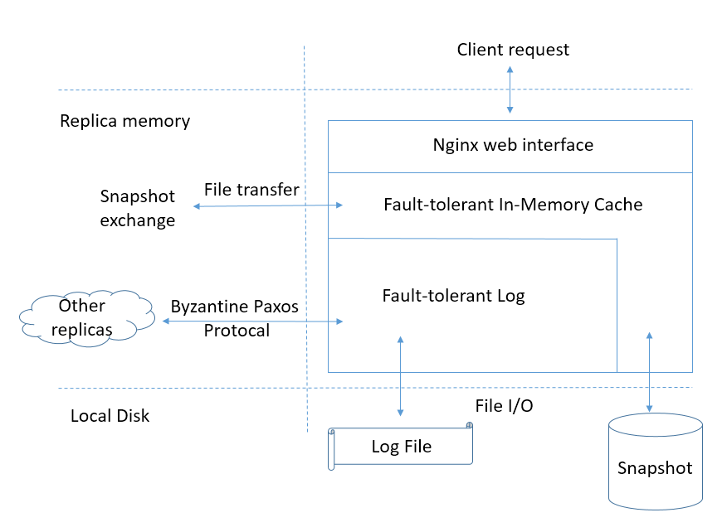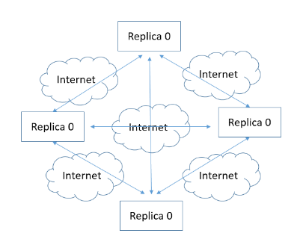
Byzantine paxos algorithm locates in following highlight part. Create, update, delete and get operations from content manager go through this core component to make sure these changes will consistent in every replica.
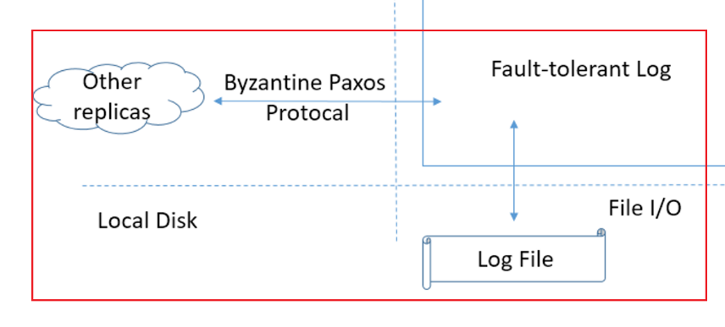
I leveraging existing implementation demo which provided by Castro and Liskov (Turing Award) [1]. This Byzantine paxos implementation demo is cited by Butler Lampson (Turing Award) [2] and Leslie Lamport (Turing Award) [3].

Which features has been done
- Basic Byzantine paxos algorithm.
- Uses the digests to check the correctness of the result.
- Symmetric cryptography to authenticate messages.
- Read-only operations optimization.
- Process requests in batches.
- Defenses against denial-of-service attacks.

Estimation for remaining features.
1 | Add enough test cases for basic byzantine paxos implementation. Remove unnecessary part. | 1 Month / 1 Person
2 | Group membership reconfiguration | 1 Month / 1 Person
3 | Handling node failure, disk corruption. Change based on current implementation | 1 Month / 1 Person
4 | Log garbage collection. Change based on current implementation | 1 Month / 1 Person
5 | Runtime consistency checking. Change based on current implementation | 1 Month / 1 Person

High-Performance In-Memory cache
After new change get into fault-tolerant log, these change will be applied in fault-tolerant In-Memory Cache which has good performance and will be the data source for external APIs.

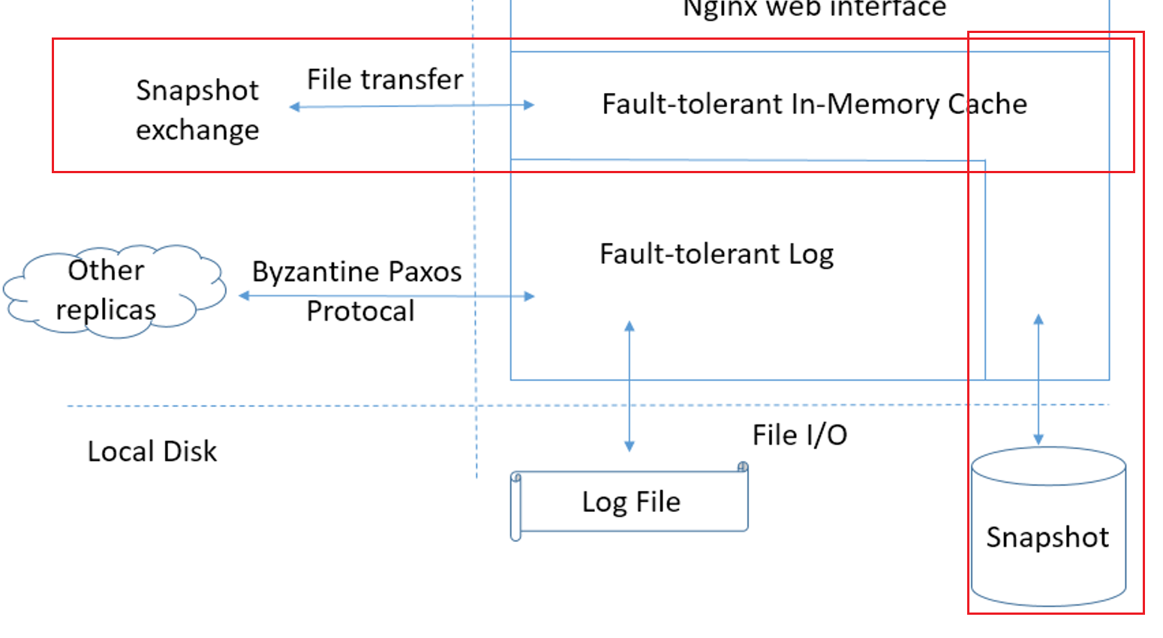

Which features has been done
I have a fully tested In-Memory cache implemented with lock-free technique and C#.

Estimation for remaining features.
1 | Translate C# implementation and test cases into C++. Fully test. | 1 Month / 1 Person
2 | Integrated with Byzantine paxos algorithm. | 1 Month / 1 Person
3 | Implementation snapshot exchange function, provide fault-tolerant capability. | 1 Month / 1 Person
4 | Runtime consistency checking. | 1 Month / 1 Person

High-Performance API service
Nginx handles front-end requests and get the data from In-memory cache.
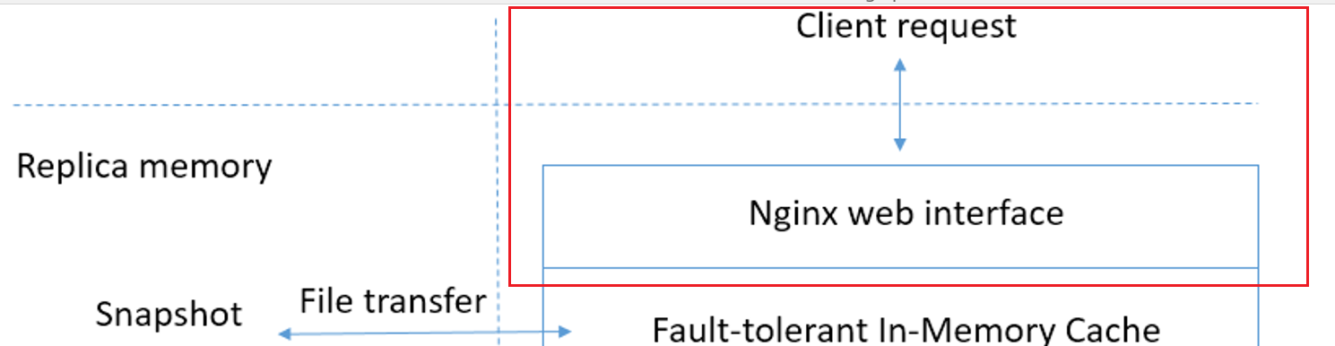

Which features has been done
Nginx is the top 1 choice for API service. Just leverage.

Estimation for remaining features.
1 | Integrated with In-memory cache. | 1 Month / 1 Person

Operation automation
Minimized Operation cost: deployment, monitor, failure recover manual effort should be minimized.

Estimation for remaining features.
1 | Automated deployment for all replicas. | 0.5 Month / 1 Person
2 | Distribute system really time monitor. | 0.5 Month / 1 Person
3 | Minimized failure recover process. | 1 Month / 1 Person

Integration with existing systems
The whole system should be easily integrated with existing system. Need more information about current system.

Estimation for remaining features.
1 | Integrate with current content manager input system. | TBD
2 | Integrate with current consuming customers. | TBD

References
[1] Castro, M. and Liskov, B. Practical Byzantine fault tolerance. Proc. 3rd OSDI, New Orleans, Feb. 1999.
[2] Butler W. Lampson. The ABCDs of Paxos.
[3] Leslie Lamport. Byzantizing Paxos by Refinement, Distributed Computing: 25th International Symposium: DISC 2011, David Peleg, editor. Springer-Verlag (2011) 211-224.

